

**Face recognition with Keras**

**Deep learning**

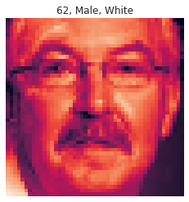

**Introduction**

In this study, face detection was performed from the images in the LFW data set.

Before face detection in LFW images, multiple face detection performed in single images.

Desired number of images are taken from the zip file in the LFW data set. Then the face detection was made from these images.

**Dataset**

I will construct three model and use three targets:

* Age
* Gender
* Ethnicity

After training models I'm going to create a function which will predict these three parameters by photo.

**Data description**

1. **Age age of the person in the image**
2. **Ethnicitysort Specifies the ethnicity of the person**
3. **Gendersort Gender of the person**
4. **img_namesort Name of the Image**
5. **pixelssort Array to String of the image pixels**

**Tools**



**Presenter**

Nasser Rashed Alqurini